Group Assignment 2: “Zombie Pandemic” and the Emergency Management Cycle

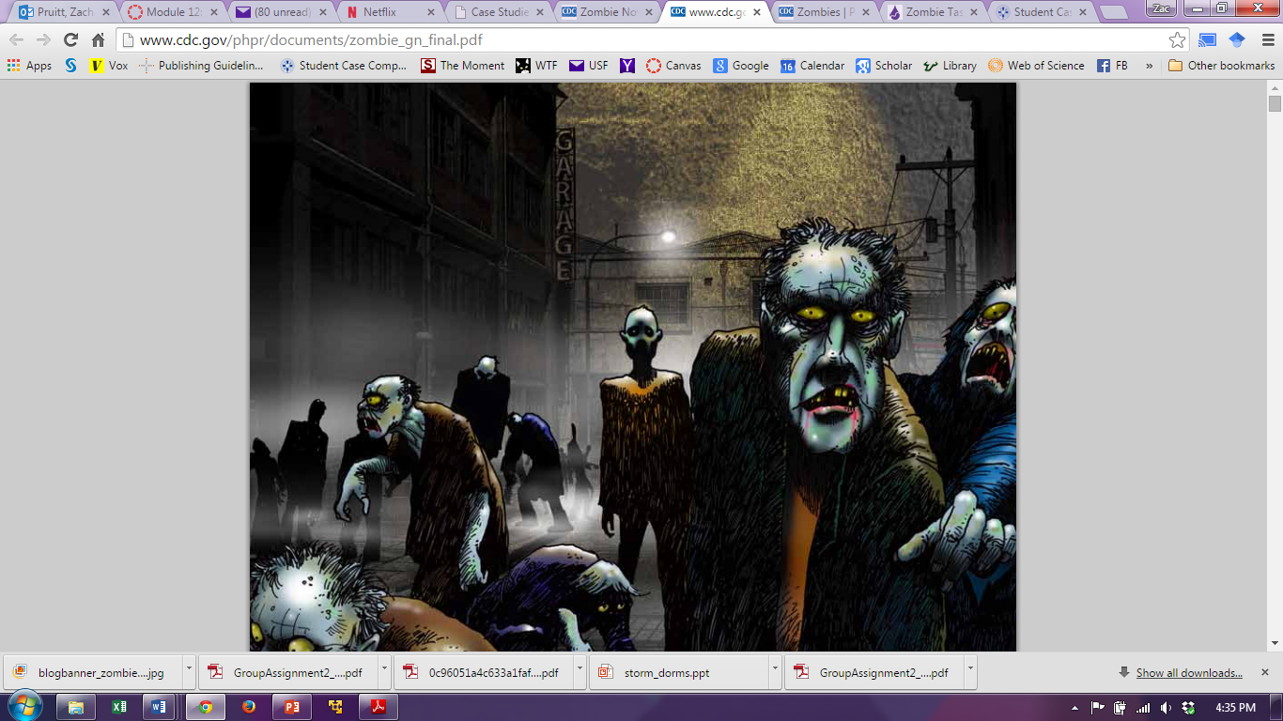

This is a discussion group project based on the “Zombie Pandemic” graphic novella from the Centers for Disease Control and Prevention. According to the CDC, “If zombies did start roaming the streets, CDC would conduct an investigation much like any other disease outbreak. CDC would provide technical assistance to cities, states, or international partners dealing with a zombie infestation. This assistance might include consultation, lab testing and analysis, patient management and care, tracking of contacts, and infection control (including isolation and quarantine).

It’s likely that an investigation of this scenario would seek to accomplish several goals: determine the cause of the illness, the source of the infection/virus/toxin, learn how it is transmitted and how readily it is spread, how to break the cycle of transmission and thus prevent further cases, and how patients can best be treated. Not only would scientists be working to identify the cause and cure of the zombie outbreak, but CDC and other federal agencies would send medical teams and first responders to help those in affected areas.”

Click here to read the Zombie Apocalypse graphic novella.

Instructions

Groups are the same as in the first group assignment. Following are a set of instructions group members must follow to receive full credit for this assignment (5 points).

As presented in lecture, the emergency management cycle is the term used to designate the efforts in protection populations from disasters. The four phases include prevention or mitigation, preparedness, response, and recovery. Each student member must select one of the four Emergency Management Cycle phases for discussion. At least one member from your group must address each phase.

- The first post will briefly define the selected phase of emergency management (prevention or mitigation, preparedness, response, and recovery), state the goal of the phase, and give examples of the activities that should take place during a Zombie Pandemic during that phase of the emergency management (4-5 sentences). While you must write in your own words, citations are not required for discussion posts. The concepts and activities should be taken from the lecture and the CDC’s graphic novella (2 points).
- The second post will be a response to another student’s, whether you agree or disagree with the other student’s definition, goals, and recommended activities for the emergency management phase they chose. You must explain why. Again using course concepts from the course rather than stuff from your favorite book or movie. Please reply to a phase that no one else has replied to. (2 points)
- Use correct punctuation, spelling, and grammar. (.5 point)
- Use public health concepts only. This means you should avoid discussing the use of weaponry, military tactics, or violence. (.5 point)
- Both posts completed by the due dates and both posts submitted to Turnitin by the due date. (a .25 point deduction will be made for each part that is not submitted on time)

You are required to copy your posts to a word document and submit the document titled ‘Group2’ to Turnitin located in the folder for the week this was assigned. You aren’t required to include your name within the document. Include the text only from both of your posts, with the posts identified as first and final.

Additional Materials:
http://www.theatlantic.com/politics/archive/2011/05/why-did-the-cdc-develop-a-plan-for-a-zombie-apocalypse/239246/
http://blogs.cdc.gov/publichealthmatters/2012/05/move-over-dorothy/
https://www.youtube.com/watch?v=Q2Gixvk7Wj8&feature=youtu.be

